Kingdom of Saudi Arabia  Ministry of Education  Eastern Province Education Department  Tarbeat Al-Ajial International Schools |  |  |  |  |  |  | Date: ……/………/..………  Subject: Computer  Grade: G6
……………… |  | Seat Number |  | ……………………………………….. |  |  |  | Student’s Name
2nd Semester Exam (1St Session) 2025/2026
Sign. | Consultative Name |  | Sign. |  | Corrector’s Name | Marks in letters |  |  | Marks  in numbers
 |  |  |  |  |  |  |  |  | 40
Question A: write the correct name of each part.
Concept | Publish | Test | Design




Concept
…………………….
…………………….
…………………….
…………………….

Design

Test

Publish

Question B: State whether the statements are (True/False).
- Sprites: A sprite is a 2-dimensional image used to visually represent an object.
- True b. False

- Behaviors: A behavior is a predefined set of actions that adds extra capabilities to the object.
- True b. False
- Computer Virus corrupts or erases computer data in a system
a. True b. False
- Malware, Spyware and Ransomware are types of computer viruses
a.True b. False

Question C: write the correct name of each part.
Action | Arcade | Educational
Racing | Puzzle | Role playing


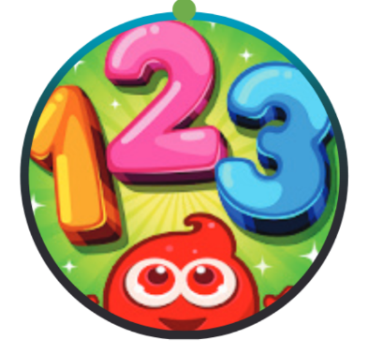

Educational
Racing
Arcade


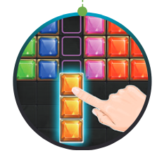


Role playing
Puzzle
Action

Good Luck

